SOLDIER Tools
Contents
SOLDIER Tools 1
Power Analyzer 2
Standard Options 2
Advanced Options 3
Team Data 4
Guild Battle 8
Standard Options 8
Advanced Options 8
Battle Details 9
Guild Battle Test 12
Zelarith’s Assignment 15
Data Diagnostics 19

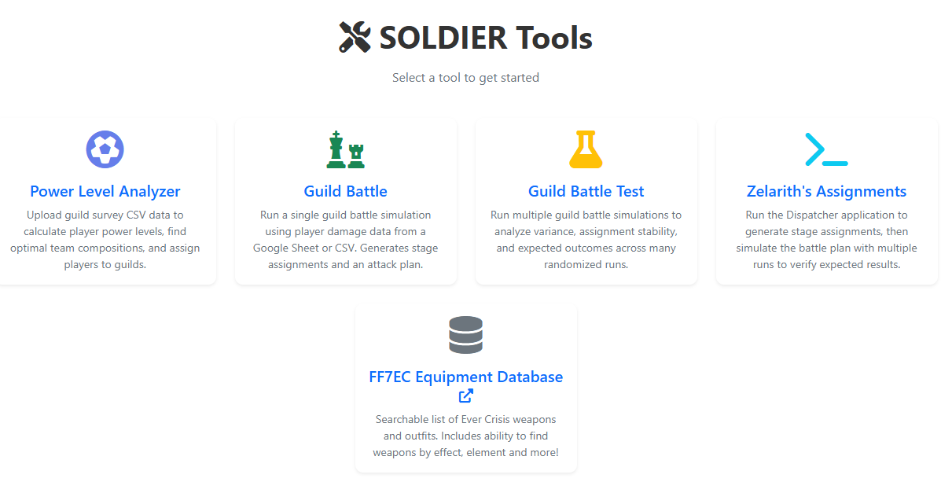

Power Analyzer
Power Analyzer is a way to attempt to rank members by the power level based upon the details asked in the gear survey. The analyzer will attempt to build out a three-character team based ONLY on the gear in the survey and rank everyone by power level. Those rankings are displayed in groups of 30 which represent the guild. Via configuration files (updated by a server admin currently) there is the ability to lock players into a guild, as well as specify guilds players can belon to. For example, guild leaders would be locked into their guild, but there may be players that do not want to be in 1st Class, so the file can specify they can only be in 2nd or 3rd class. The UI is very simple, but at the same time, very detailed and complex.

Standard Options
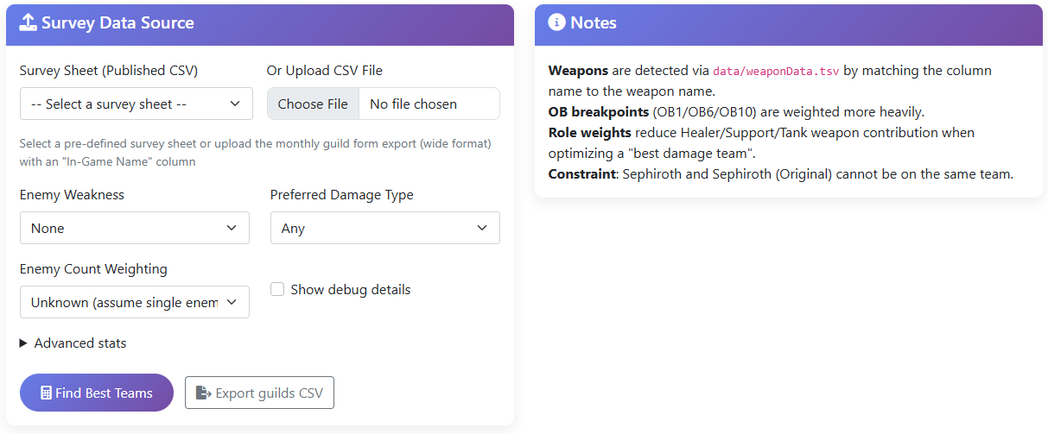
In the Ui you have the option of choosing a configured shared gear sheet or uploading a CSV file. An admin can add additional shared sheet via a configuration file and should be done as part of standard process after the gear survey is created. You can also view the gear sheet and download it as a CSV from Google Sheets. This CSV can be uploaded directly into the UI. Both will achieve the same starting result.
After choosing the CSV, you will set your weakness element and damage type. This will match the guild battle announcement which will note what is effective. You also have the option to specify if there will be single or multiple enemies, which will allow the analyzer to put additional focus on AOE weapons or not. Most of the time we do not know this ahead of time, however occasionally there will be a datamine note of what the boss, or bosses, could be.
At this point, you can click “Find Best Teams” to display a list in the UI, or “Export Guilds CSV” which will export a CSV version of the same data. The CSV version can be useful for sharing for the leads to look over as it is a very simplified view.

Advanced Options
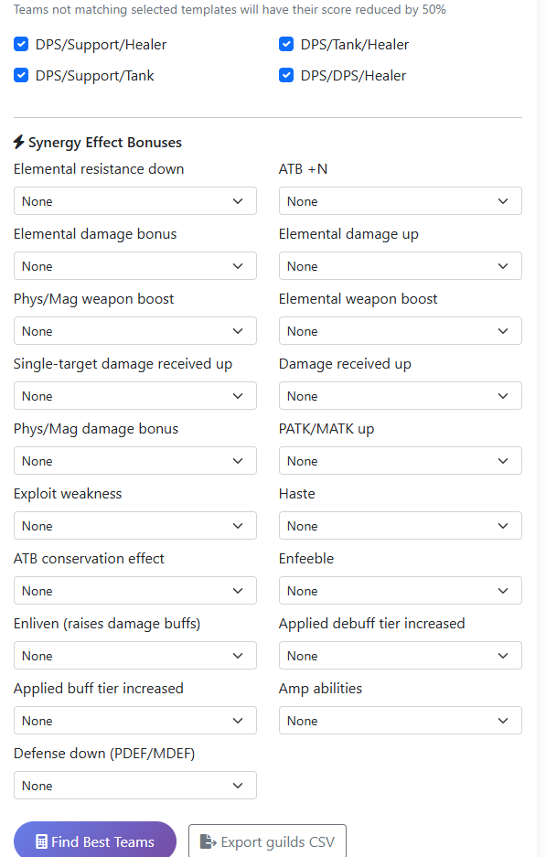
We also have several advanced options. Under advanced, you can see all the valid team configurations the analyzer will attempt to assemble. These team options can be configured via a configuration file, updatable by an admin. By default, all available team configurations will be analyzed, however we can choose to eliminate a team type if we do not feel it will be valid for this battle. For example, DPS/DPS/Healer may be a tad bit aggressive for some battles but not others.
We can also add weight to specific buffs, debuffs and statuses. It is rare that we have specific data about effects needed for a guild battle, but if we do happen to know we can adjust the weight of them here. You can add an additional 100, 200, 300, 400 or 500% to the weight of that element in the synergy detection.

Team Data
Once you click on Find Best Teams, you will be presented with a lot of information.

Survey Submissions
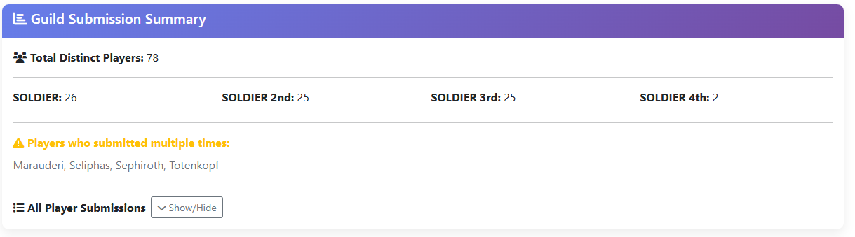
The Guild Submission Summary will give you details about the data submitted by the players. This is entirely based around data entered by the players. If they happened to choose the wrong Guild Name in the drop down, the counts may appear off. This panel will also note users who have submitted multiple times. The analyzer will automatically take the latest submission by the user. You can also expand All Player Submissions to show all the player and Discord names that have submitted a survey.

Best Teams
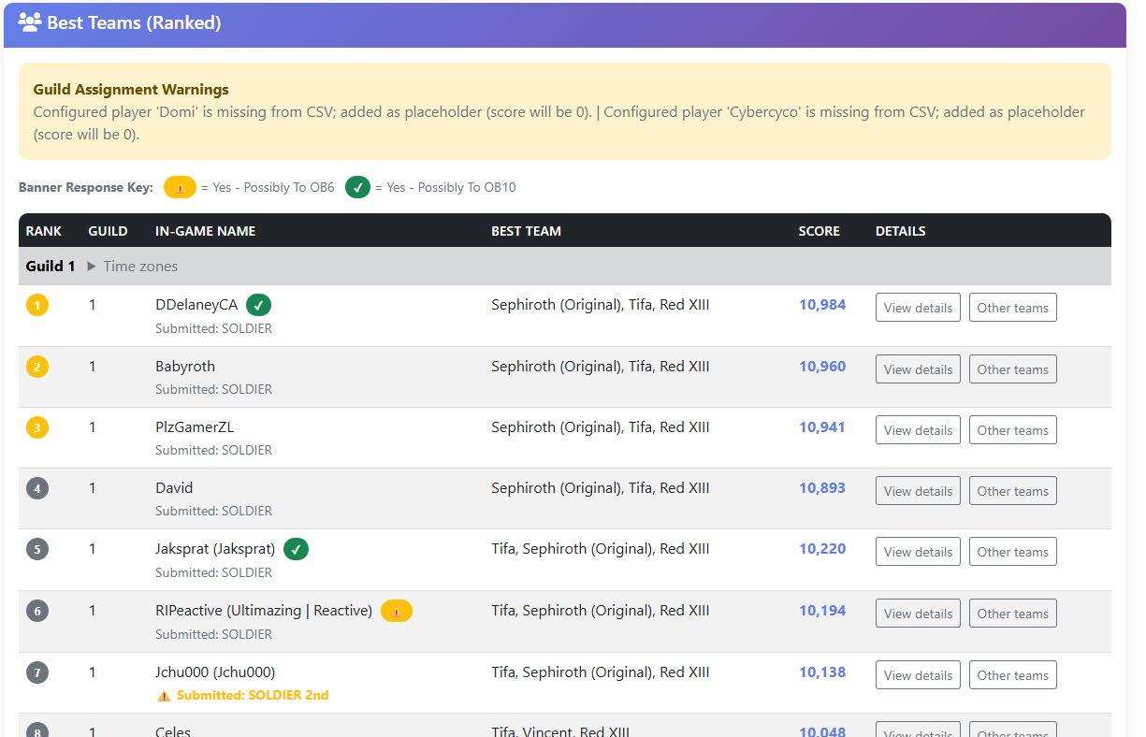
This is where the bulk of the information will come from. If a player is configured to be locked into a guild, they will appear on the list regardless of whether they submit a survey or not. If they did not submit a survey, you will see a note explaining their score will be shone as 0 in the rankings.
In the survey we have recently started asking a question about whether the user plans to pull on the guild battle release day weapon. Occasionally these weapons are useful for battle. This question does not affect their rankings, but it is noted in the UI because it may help make decisions about team placement. If you have two users relatively close in score, but one plans to pull a new banner to OB6 or OB10, it may be worthwhile moving them to the higher guild. But these are decisions that need to be made by the leads at the time of sorting.
In the rankings, you will also see if the user’s submitted guild is different than the one they are placed in. If a user submits information that they are in 2nd Class, and now they are ranked in 1st, under their name the submitted guild will appear in yellow. This makes it easy to identify players that should be considered for guild movement.
For each player you will see their top-rated team and their score. Again, these numbers are only based on the gear in the gear survey. They are primarily driven off their top DPS character, but more on that later. It is very possible that the team assembled by the analyzer will not be the best team for the battle. So, while this ranking is standardized to the point where the numbers are trustworthy, it does not mean it can accurately judge best about the upcoming battle, so discretion is advised.
For each user you will see a “View details” as well as an “Other teams” button. If you click on other teams, you will see other team compositions that the analyzer put together based on synergy detection.
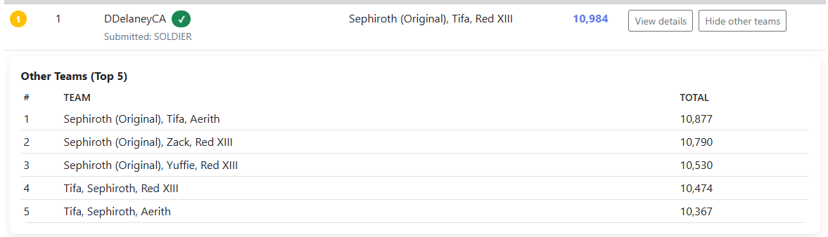
This will not show any details but will give you a brief overview of other considerations for the player and how the rank. This can be useful to identify possible discrepancies in a user’s account, where they may have a character that is just not built up enough, as well as to help identify areas where the analyzer could be adjusted to produce better results. For example, for magic fire, the team of OSeph/Lucia/Aerith ended up being used for battle. However, because Lucia’s Rifle is physical fire, the analyzer was deprioritizing it for use. Seeing these other teams score allowed adjustments to be made so the correct team was chosen.
The View details section has everything selected for the player’s team. Characters, weapons, outfits, materia, summons and enemy skills along with the bonuses and scores they provide.
The Applied Rules section is a general overview on how the scoring works. It is a very, very brief description of some of the logic used by the synergy detection and scoring.
The Battle Context section will represent the details selected in the options.
The Team score section is the final score of the team after multipliers.
Team synergy bonus is a score applied by the culmination of the effects provided by the weapons and outfits.
Materia bonus is a small number of points based on the materia potency.
The Utility Bonus Items section is primarily enemy skills.
After those items, you will get into the character breakdown. Ultimate Weapons, Outfits, Main Hand and Off-hand will all be processed. Only DPS characters will have points that scale off the OB level and potency of their weapon. Since the DPS character is going to account for most of the damage, this will drive most of the team’s points. Other characters will get small boosts for OB levels, but the potency percentage will not have any effect on their score. This mechanic is what allows a physical weapon with effects that benefit the battle to be considered for use in a magical battle, and vice versa. Teams with 2 DPS characters will score much higher as both will have their weapon potency applied to the score.
Adjustments to synergy will need to be made as new effects, buffs and debuffs are added to the game. Additional adjustments will also need to be made to help the engine make better choices about team builds and weapon selection.

Guild Battle
Guild battle is a dashboard along with an assignment and simulation page. This will do one simulation run and display the results of that run.

Standard Options
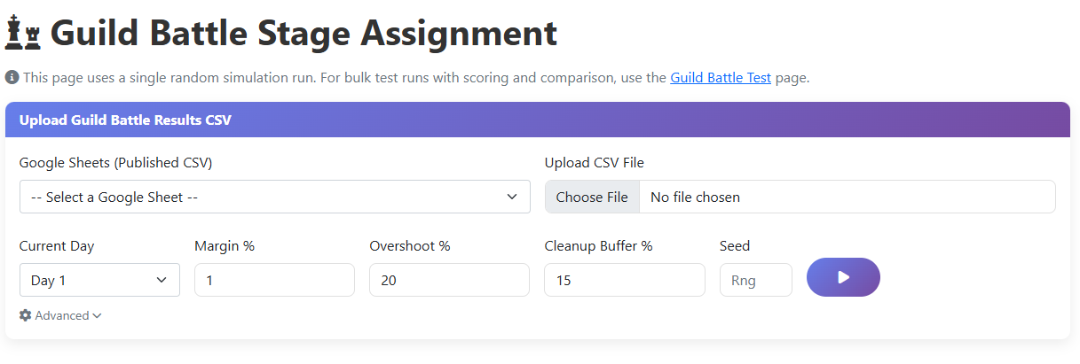
The standard guild battle sheets have been configured for 1st, 2nd and 3rd using the Google Sheets published URL and can be quickly chosen from the drop down. You also can upload a CSV version of the Spreadsheet that you can download from Google Sheets. Downloading the CSV can be useful if you want to capture a moment in time. The live sheets in the drop down could be updated by a player during the day.
Current day should match the day of the guild battle. This will allow the simulation engine to understand exactly where we are in battle. Choosing the wrong day can lead to unexpected results.
Magin % is the margin of error in players attacks. We all know that guild battles do not always go smooth, and your mock percentages may not always hold true. Setting this number will introduce more variance in the player’s simulated runs. It is recommended this be set to between 0-5%.
Overshoot % is when the simulation should start considering other players. If there is 15% left on a stage, and a player can do 45% on that stage, that is a 30% overshoot. If it sees a player that will overshoot by the set percentage, it will look at other players. It will use Cleanup Buffer % to make sure the next player it chooses can safely hit that amount. The best example is on higher stages and when there is a small percentage left. You do not want a player who can do 15% on stage 6 to normally clean up less than one percent, instead you try to find a lower power player that can clear that stage, saving the higher player’s attack for a full run. The simulation will attempt to mimic that decision making and promote a player from a lower stage to save battle percentage.
Seed is used to see the result of a specific simulation. More on this later.

Advanced Options
Under advanced options, you can specify the boss HP.
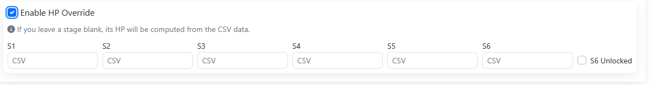
The app will attempt to use the CSV data to calculate the remaining HP of all stages. However, there are situations in which players do not log their attacks immediately or they enter incorrect percentages. These data issues can cause the simulation for start with incorrect data. To allow for a more realistic simulation, this allows you to put in the exact HP of each boss instead of calculating from the CSV. If a value is left blank, it will still be calculated. The S6 HP value will not be applied unless you check the box which says S6 is unlocked. Otherwise, it will assume it is not and do the calculations. This prevents a user from having to enter 0 which could cause issues in simulation.

Battle Details
Once the simulation is complete, you will be presented with a full dashboard. On the left you will have a basic summary of the remaining attacks and HP of the bosses. Under that, if you have selected day 2 or day 3, it will call out any missing attacks. If you have selected day 1, or all attacks have been accounted for, this panel will not display. The third panel on the left will be the players percentages. This will be the player’s mock data averaged with any live runs they have done, which should result in a more correct number.
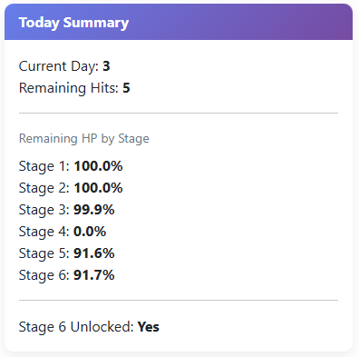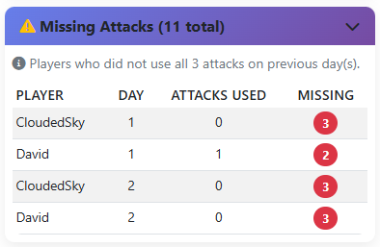
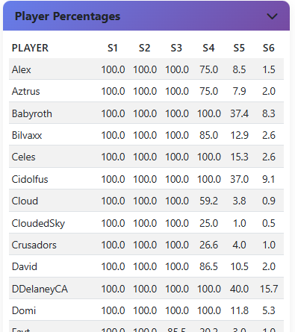
On the right you will be present first with the expected overall reset, and the clear per stage. After that will display the expected final HP of the stages.
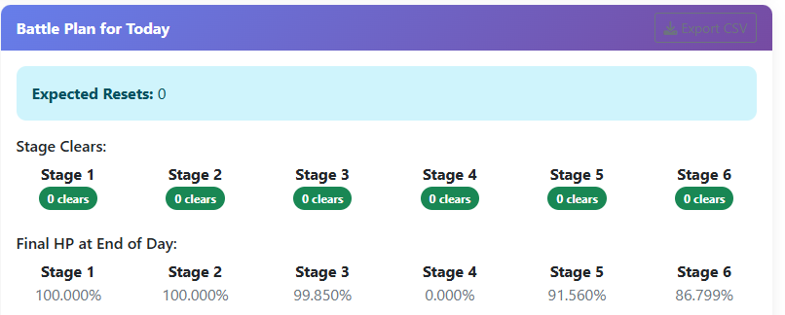
After that panel will be the simulated attack log. This log will display the player, stage, the percentage they cleared, the remaining HP, the estimated number of points they scored and whether the stage was cleared. Resets, cleanups, promotions and demotions will be noted in logged rows of the attack log. At the bottom of the log will be the total point for the day.
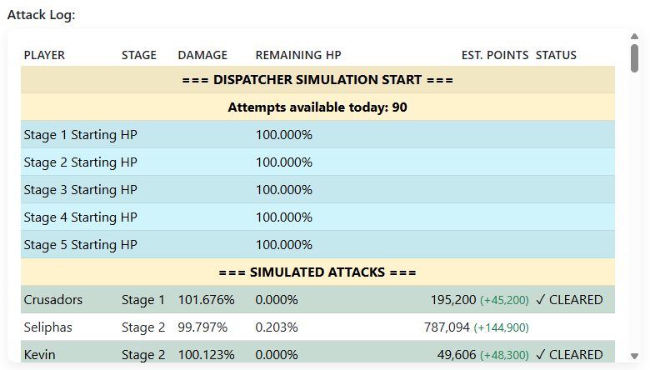
The panel after that will show the stage assignments it used. Note: this is not the same assignment logic used by Zelarith’s app. This is a much looser and early build of assignment logic. It is a representation of the assignments the simulation used for that run. This logic does not split a user across stages at the time of assignment but assigns all their attacks to one stage. It will move the player as needed during the simulation.
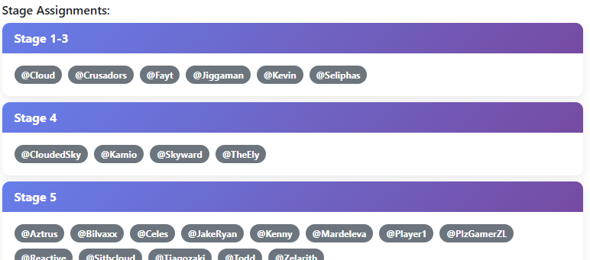

Guild Battle Test
The test page is a multi-run interface for the Guild Battle page. This allows you to upload the same data, but this time do different simulations to find the best one.
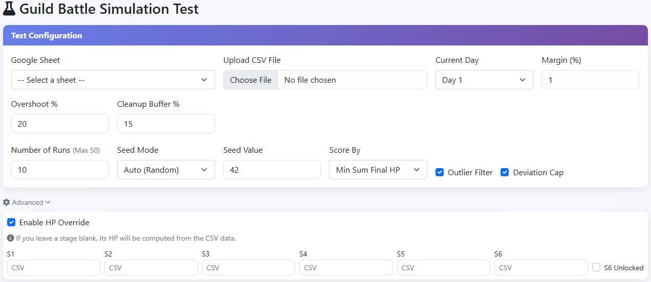
The test page has all the same options as the Guild Battle page does. This includes the standard and advanced HP options. However, it adds a few extra options used in the simulation.
Number of Runs is the number of simulations you want performed.
Seed Mode is how the handle the seed numbers in the simulation. By default, it is set to Auto. If you set it to “Fixed”, it will use the Seed Value input and run that simulation each run. If you set it to “Incremental”, the simulations will start at the Seed Value input and increment up by one each run. For normal use, this should be left to Auto.
Score by will be the logic used to determine the best run. “Min Sum Final HP” will look for the highest number of reset, and then total up the remaining HP, which more weight put on the higher stages. “Min S6 Final HP” will choose the best run with the lowest S6 HP. “Max Total Clears” will look for runs with the highest number of clears.
Outlier Filter controls whether “cleanup” attacks get discarded when recomputing player averages. If a player does a cleanup on a stage for a small percentage, enabling this check will prevent that small attack from skewing their averages.
Deviation Cap works alongside the Outlier Filter. When checked it guarantees each player’s average percent won’t fall below 70% of their mock percent. This prevents live attacks from crashes or freezes from dragging down a player’s average.

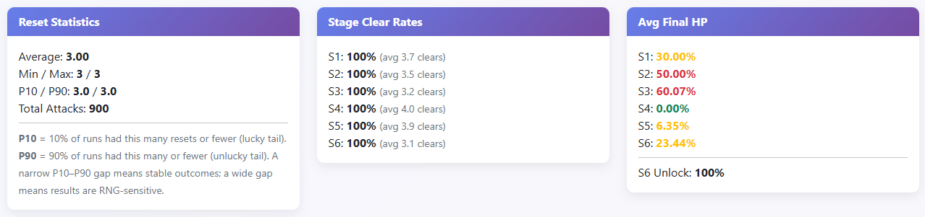
After you click “Run Simulations”, you will be presented with data about the simulated runs. The first panels will be overall stats about the runs that were just performed.
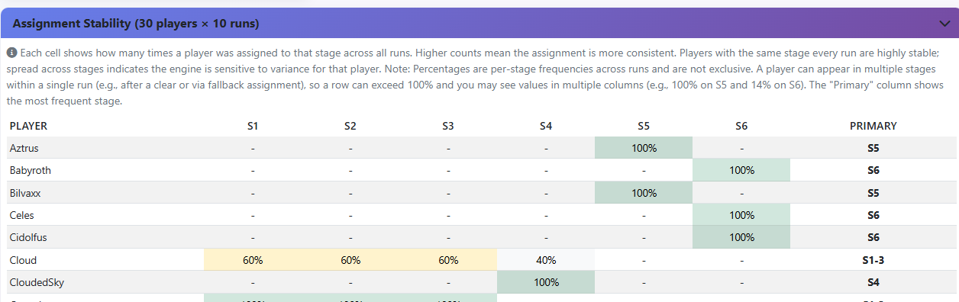
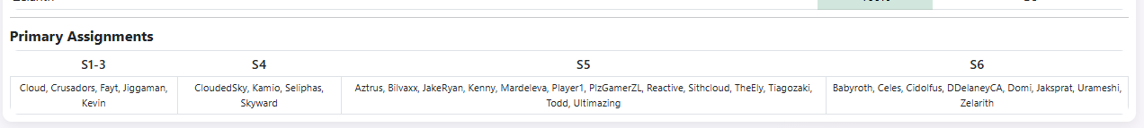
After that, you will see the assignment stability of a player. This will indicate where most of their attacks ended up over the full number of runs. The last column will indicate where their primary stage assignment was. Next will be a table of the primary assignments for quick reference.
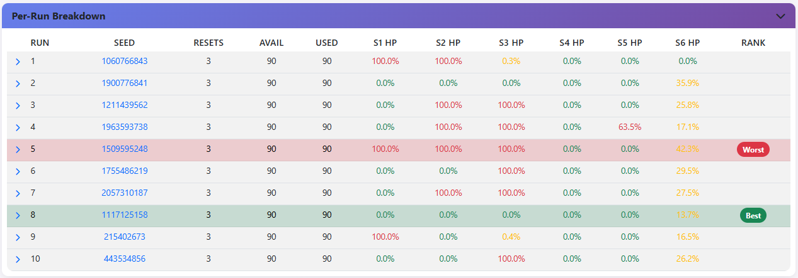
Finally, the per-run breakdown. Each row can be expanded by clicking the arrow to view the assignments for that run as well as the attack log. The best and worst run based on the criteria selected will be noted.
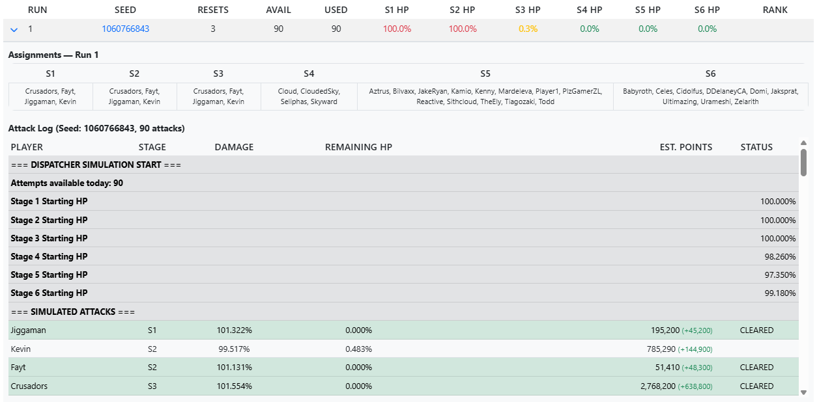
In addition, you can click on the seed number value, and it will populate the needed information on the Guild Battle page. You need to select the same Google Sheet or upload the same CSV file to get the same results. When you do, it will replay the same simulation and allow you to view it in the full dashboard.

Zelarith’s Assignment
Now that we have discussed the simulations, we can bring it all back together with the application Zelarith has built. Zelarith has put a lot of effort into determining how to best prioritize players to get the best clear. Guild battles do not always go perfectly, and adjustments need to be made on the fly. This last base is a combination of that assignment logic and the simulations from the prior pages.
Please note this is running an external application inside of a web page, so at times it can be a bit fragile. If you get an error, it is best just to try again. Also, currently this can only be used by one person at a time. If multiple users use this page at the same time, you might get unexpected results as it relies on writing out a text file for the program to consume. Multiple users writing the same file could cause errors, so this page is best left for the leads to handle.
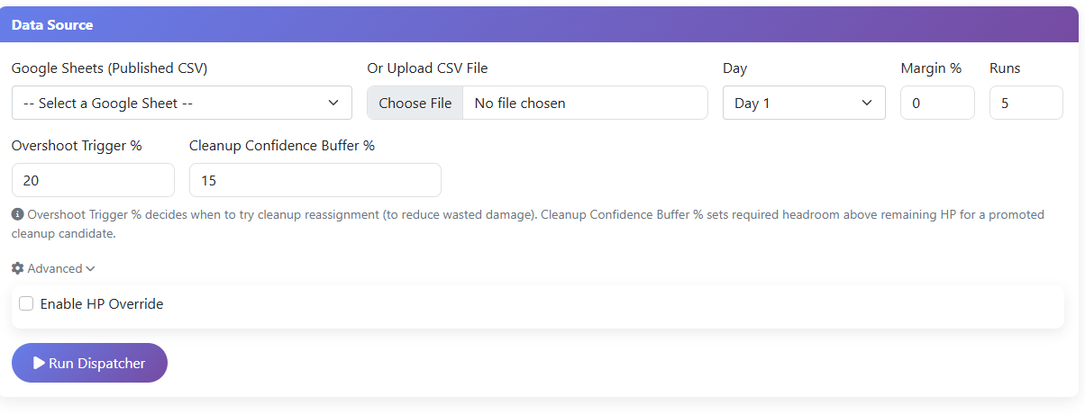
The input options are much of the same as has been previously discussed. This included standard and advanced options. Once you click Run Dispatcher there will be a lot of information presented. The first few panels display as collapsed by default. The first is Stage HP Computation.
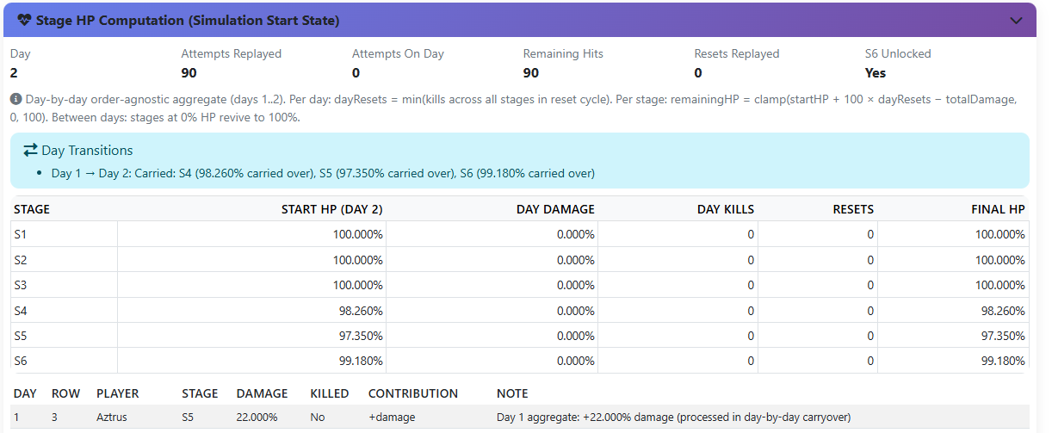
This panel will show how the simulation determined the starting HP for the bosses. This allows you to visualize the calculations and use the advanced options if necessary. These values are not used by Zelarith’s app, but they are used by the simulation engine.
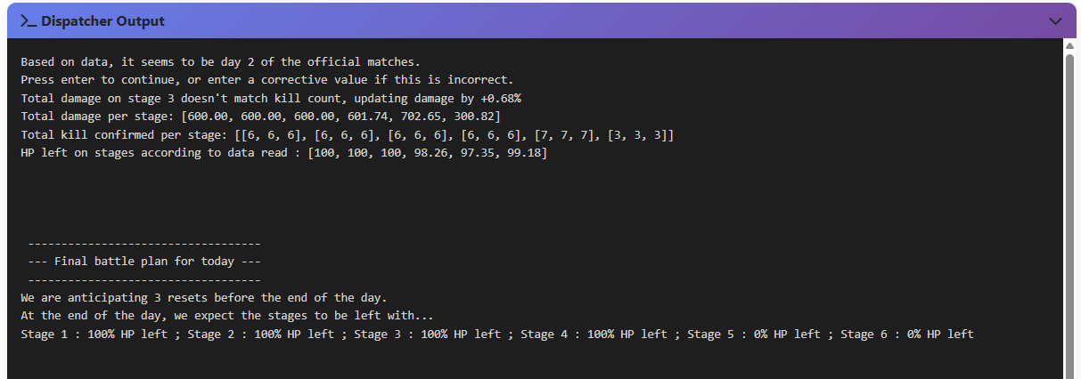
The next panel is the dispatcher output. This is the actual console output of the application as it runs. This will look familiar as it is the same output we use in the stage assignments channel.
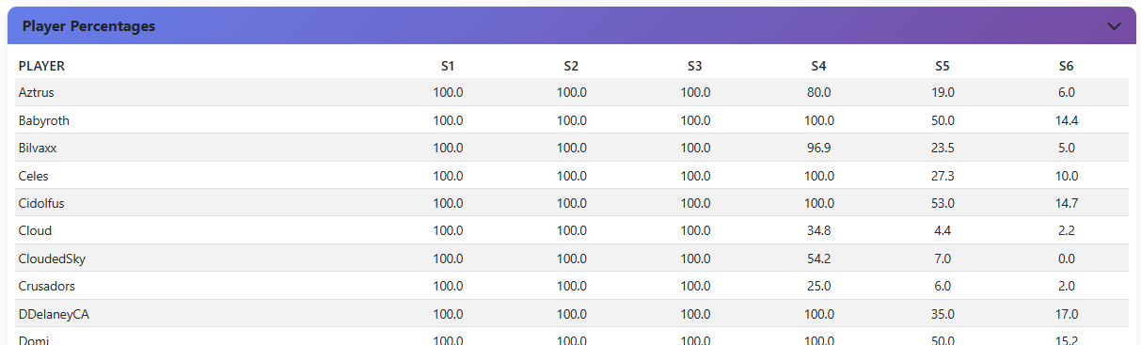
Next is the player percentages from the spreadsheet. This is the exact same data shown on the Guild Battle page. This is the player’s mock values averaged in with their live attacks. These values are not used by Zelarith’s app, but are used by the simulation engine.

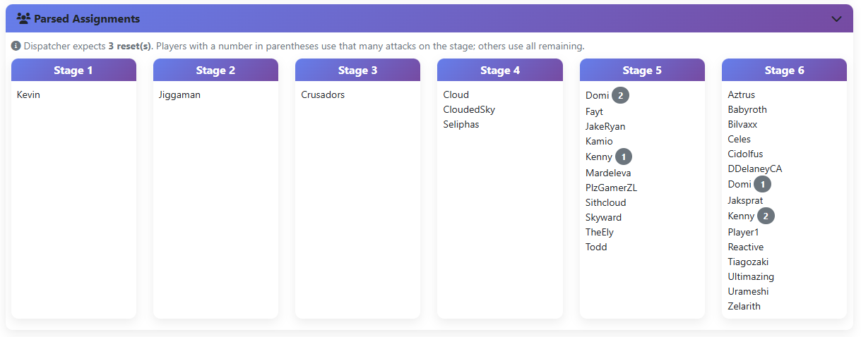
The first expanded panel will be the values we parsed from Zelarith’s application. The numbers next to the names represent the number of attacks per stage the player is expected to do. Traditionally we don’t split a user up at the start of a day across stages, but the app does account for it.
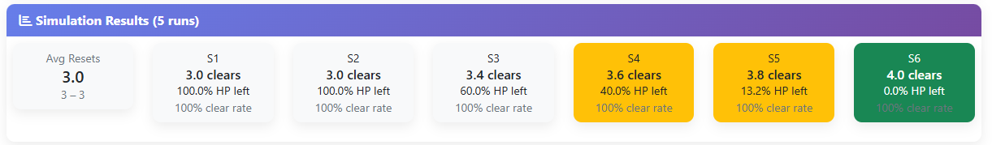
The next panel will show average stats for reset and stage clears for the number of runs requested.
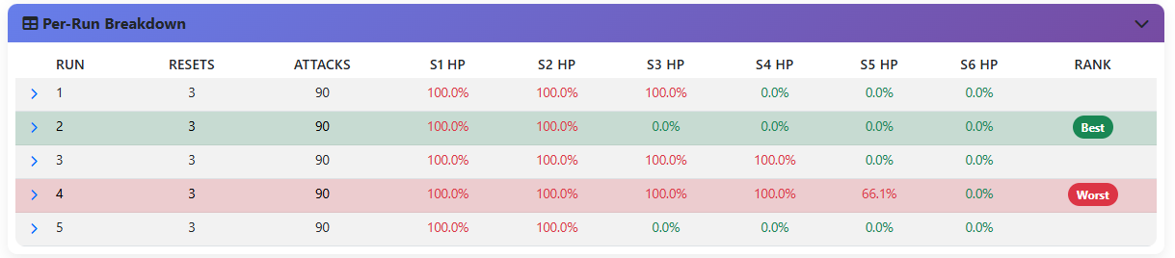
Next will be the per-run breakdown of each run. This will be very similar to the Guild Battle Test page except there will not be a seed number since we are getting our stage assignments from Zelarith’s application. These runs will differ in RNG causing different results. Actual runs will vary. You can expand each row to see the attack log for each run.
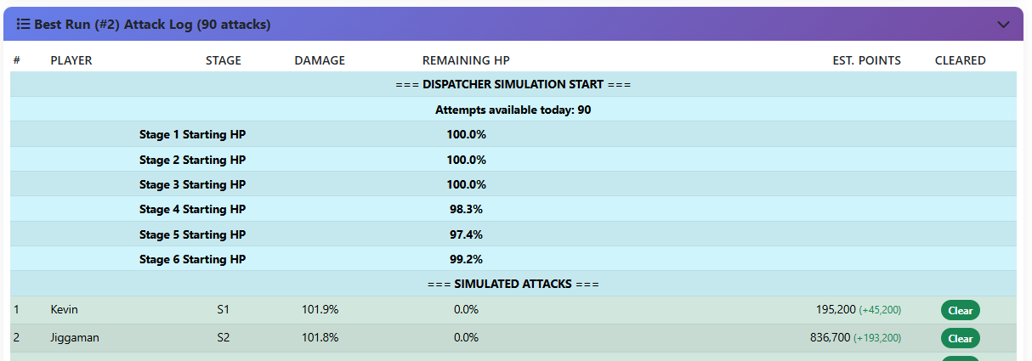
The final panel will be the actual attack run for what it determined to be the best run. This will match the expanded row attack log for the run labeled “best”.

Data Diagnostics
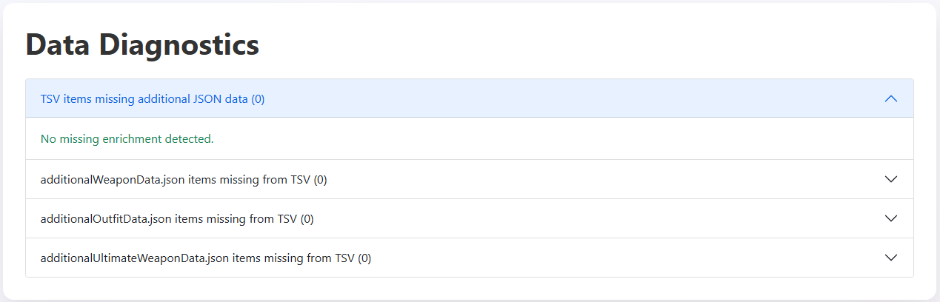
There are several files used by the Power Level Analyzer to get weapon and outfit data. These checks ensure all the data is available. The main weapon database is the TSV file maintained by CypherSignal. This file is missing some data such as older outfits and weapon R Abiilties. If an item is added to one of these files, but it did not get added to a corresponding file, this will indicate the missing data allowing an admin to correct the issue.

